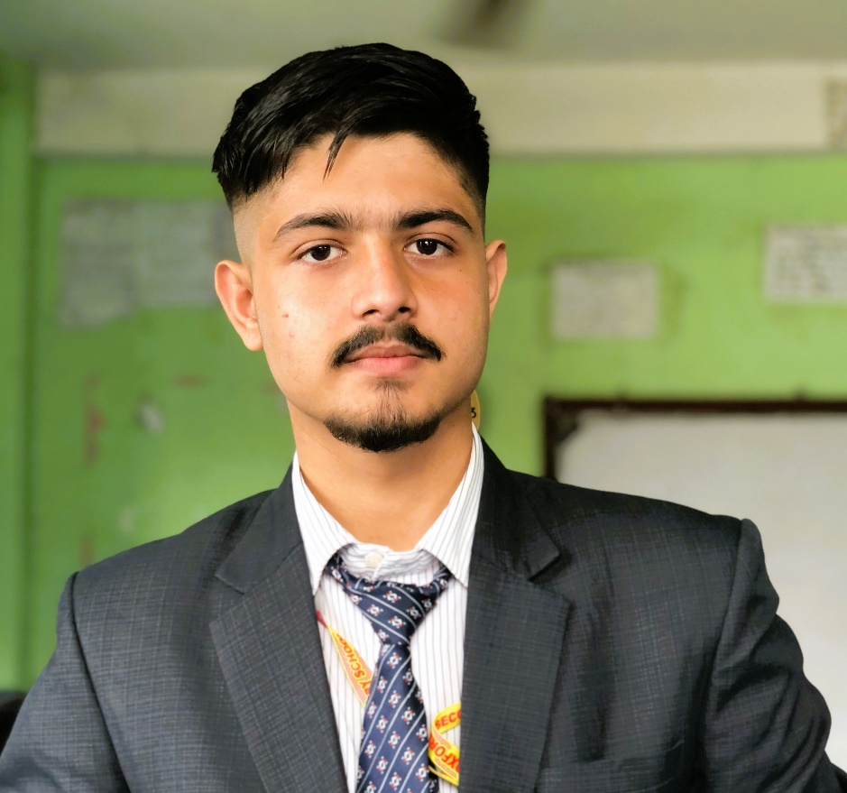

Reflective Essay

A Symphony of Words: Reflections on My Growth as a Writer

This semester in ENG-1100 has been a transformative experience, offering me a deeper understanding of effective writing and critical thinking. My portfolio title, "A Symphony of Words," represents how each essay and reflection in this course contributed to creating a harmonious narrative of my growth as a writer. Like a symphony, my work combines distinct elements—personal stories, analytical skills, and structured arguments—to form a cohesive and meaningful whole.

The Literacy Narrative marks the beginning of my journey, where I reflected on my roots and academic transformation from a rural school in Nepal to embracing technology in a global context. The Summary and Response essay challenged me to evaluate an argument critically, allowing me to engage with and question existing ideas. Lastly, the Text Analysis essay pushed me to dissect rhetorical elements in opinion pieces, honing my ability to assess and synthesize information effectively. Each essay showcases a different skill, highlighting my growth in narrative storytelling, argumentation, and critical analysis.

Throughout this course, I faced challenges in organizing my ideas and balancing personal anecdotes with analytical depth. However, with peer and instructor feedback, I learned to revise effectively, refining both structure and style. The most significant improvement came in my ability to craft thesis-driven essays with clear support. Yet, I still struggle with integrating evidence seamlessly—a skill I aim to improve in future coursework.

Looking ahead, I plan to apply these skills to technical writing in computer science, where clarity and persuasion are essential. My immediate goal is to practice integrating evidence smoothly and revising iteratively to achieve polished drafts. This portfolio is not just a reflection of my academic growth but a foundation for continued learning and exploration.

Essays

1. Literacy Narrative: Final Draft

A Symphony of Transformation: From Rural Roots to Future Innovations

C:\Users\User\Documents\Custom Office Templates\Literacy Development Narrative - Second Draft revised after your feed back.docx

2. Summary and Response: Final Draft

“Is College Worth It?” by David Leonhardt

C:\Users\User\Documents\Custom Office Templates\Summary&Response revised version after final feedback.docx

3. Text Analysis: Final Draft

“How Technology Is Changing the Future of Higher Education” by Jon Marcus

C:\Users\User\Documents\Custom Office Templates\Text Analysis - revised as feed back.docx

**Final Notes and Submission**

This portfolio reflects my engagement and effort throughout the semester. By revisiting and refining each essay, I see how my writing has evolved, driven by feedback and reflection. Each piece contributes to a narrative of growth, ready to serve as a stepping stone for future academic and professional challenges.